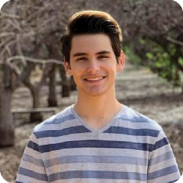Mick Arias

Student

1 Profile Details

A passionate Java and Web developer with the willingness to learn, adapt, (480) 888-6952

and move forward with a well thought out solution. Will bring a new [mick756@gmail.com](mailto:mick756@gmail.com) perspective to a team as well as a friendly and motivated personality.

# Employment History

Shift Manger at Carl's, Jr. StarCorp LLC, Mesa. AZ

December 2016 — September 2019

As a Shift Manager my responsibilities were keeping track of inventory, working very well with time restrictions, managing co-workers as well as properly communicating with customers to solve issues.

# Courses

Full-Stack Web Development, UofA from Trilogy

July 2019 — September 2019

Computer Science 110 (Java), Mesa Community College

September 2019 — September 2019

# References

Tucker Beauchamp from 2U Education

[tuckerbeauchamp@gmail.com](mailto:tuckerbeauchamp@gmail.com) (661) 361-3839

Education

High School Diploma, Red Mountain High School, Mesa, AZ

August 2015 — May 2018

**Certificate, Full-Stack Web Development, Chandler, AZ**

September 2019 — September 2019

HTML, CSS, JavaScript, Handlebars, Node.js, NPM, Yarn, Express.js, MySQL, MongoDB, ORMs, and React

Projects

PartlyFancy, Mesa

September 2015 — September 2019

PartlyFancy was an add on to the game Minecraft that used Java conventions and logic to track players, generate circles, as well as manipulate arrays.

# Extra-curricular activities

Performing Arts, Mesa, AZ

August 2012 — September 2019

Date of birth

11/22/2000

## Links

My Website

Linkedln

Languages Spanish

## Skills

Java JavaScript Node.js CSS HTMLS MySQL

MongoDB React Spring